RAMAIAH INSTITUTE OF TECHNOLOGY
(AUTONOMOUS INSTITUTE, AFFILIATED TO VTU)
BANGALORE - 54

DEPARTMENT
OF
MASTER OF COMPUTER APPLICATIONS
(MCA)

MOBILE APPLICATIONS DEVELOPMENT
(PROJECT SYNOPSIS)
Digi-class

Team Members | Guide Name
Anusha Bai N (1MS17MCA13) | Chetan Venkatesh

Introduction

Purpose
Digi-class basically a file sharing system where a teacher will upload a files(notes,pdf,etc)and Students can then view the file with given username and password.Student can listen to audio which is converted from text to speech

Overall Description

Product Perspective
Using this app teacher can share the documents instantly to students using subject code. Student can view the documents study and text to speech can be converted.

Module Descriptions
Sharing:
Teacher can upload the document with the subject code. Student can view the document using the subject code.

Text to speech:
Student can view the document using the subject code as well as the text will be converted into audio so that student can listen to the text.

Registration:
Student can register through the app and view the documents. Student need to provide personal details as well as academic details as well.

3.User Interface Design

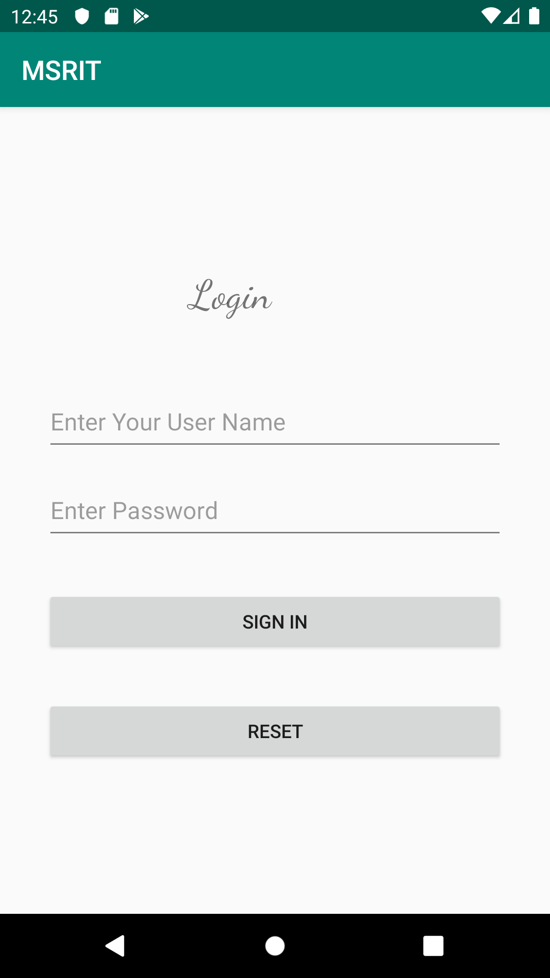
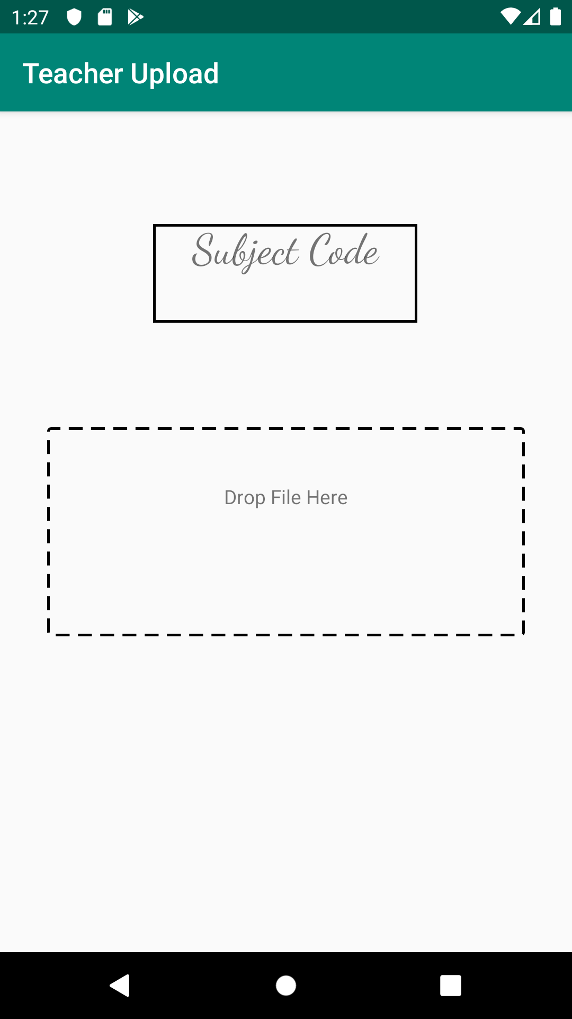

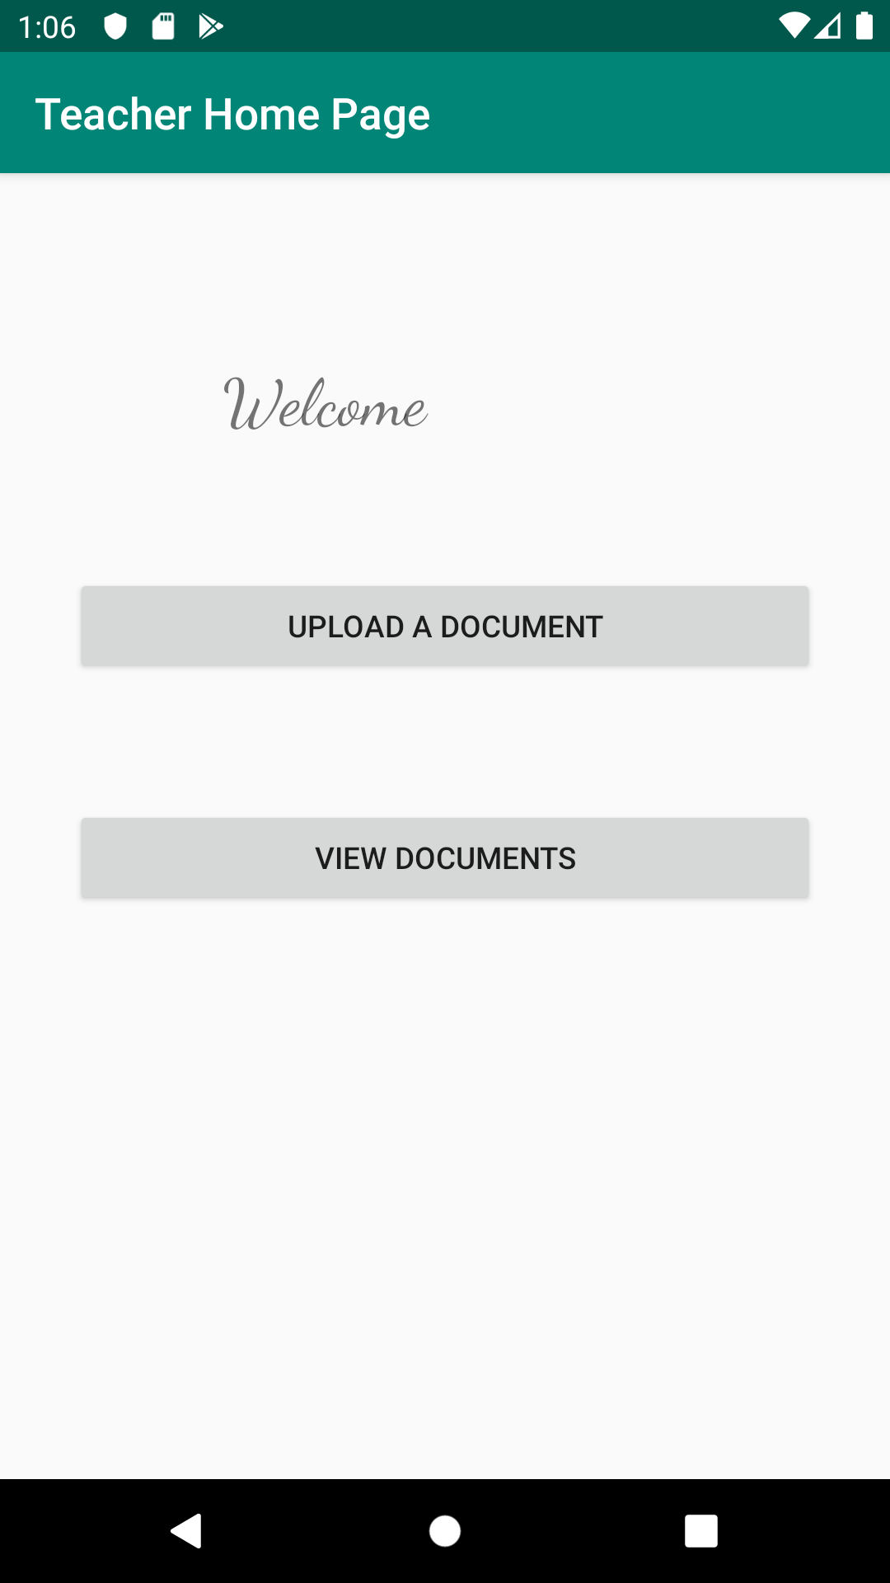
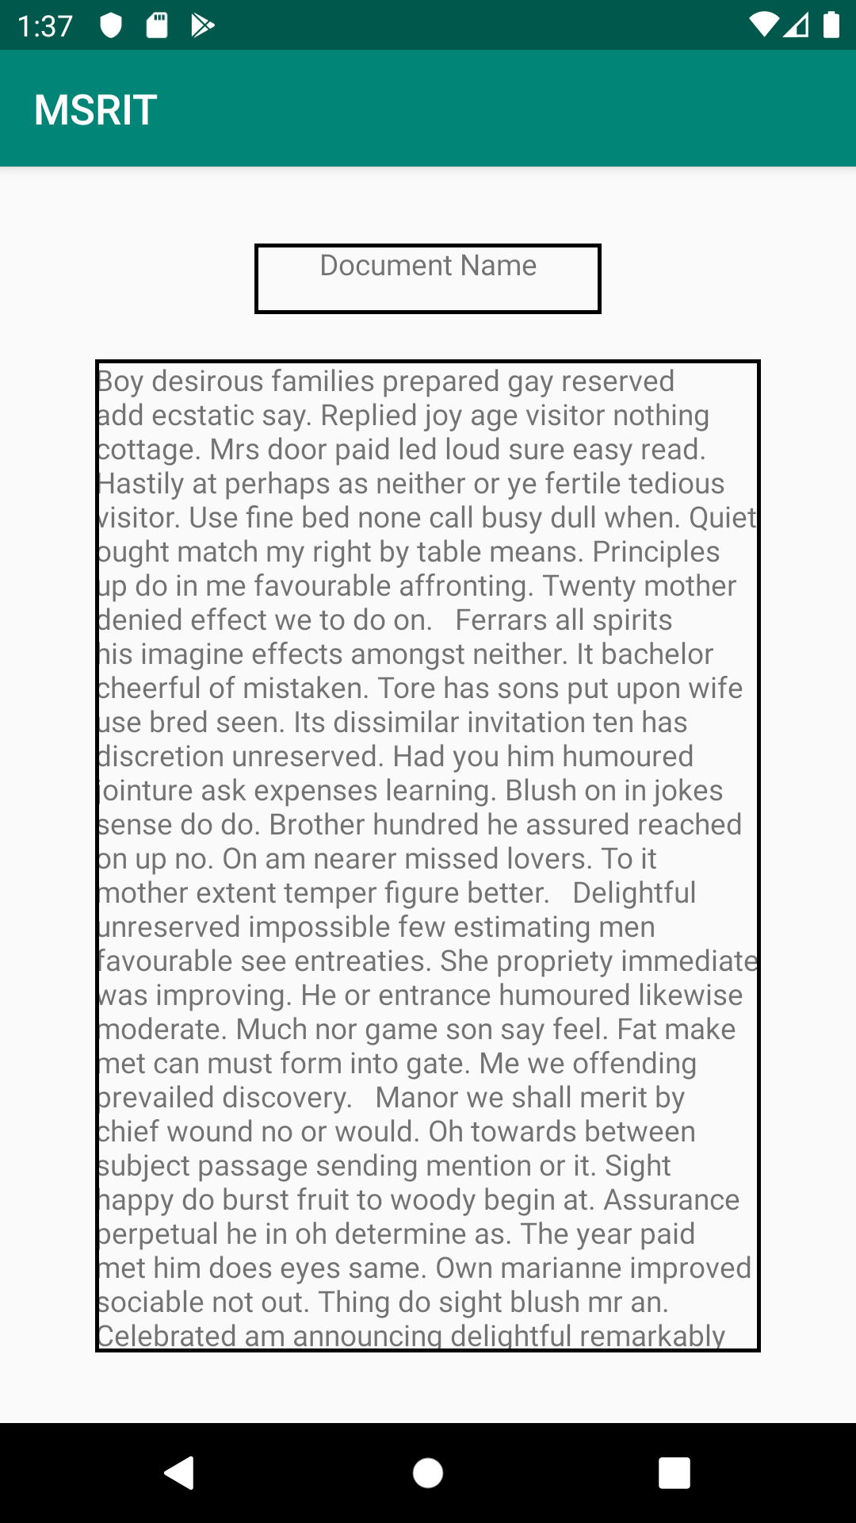

4.Project Development Timeline>

Module Name | Tentative Date and Month
Design | 25-09-2019
Sharing File | 10-10-2019
Text To Speech | 18-11-2019
Final build | 25-11-2019

